Dessa Shapiro

2/8/21

Period 7

**Traveling through imagination**

If I were to travel anywhere, where would I travel? Maybe to others, it seems a simple question and they would answer a mundane response such as a tropical island or a beautiful mountain. But, I feel that if I knew I had the option to travel and learn anywhere, I would not include it to only the surface of reality we recognize. I would believe myself capable of viewing a more creative destination that could include my imagination, or to journey into the molecular structure of an atom. For the sole reason being that no one has ever known what one looks like or maybe even how its structure works. I have concluded people probably know much less of what they believe, and that this false sense of knowledge gives them a sense of surety whilst constantly surrounded by the unknown. Possibly I would wish to travel in a human mind, and I don't mean the literal sense of brain tissue. I am more referring to the way thoughts are formed and why people react to different things, why we as a species desire control over things. In these statements I am not differentiating myself from humanity in any way, I partly wish to learn this specific information so I can understand my mind better and why I tend to mentally contradict myself so much. In truth, I would consider traveling to an even greater place or vision. Somewhere or something that would envelop me in an aspect completely unknown such as learning a new sense or allow me to see new colors or even rewire my brain to interpret emotions or thoughts differently. I do not desire the answers of the universe or the creation of all things, and I believe that a quality I share with very few. Even if such a thing was offered to me I would most likely decline because too much information can hold too much power, and power can break people. I only desire to find some spark on this journey that I attend within the confines of my mind. I wish to find something to hold onto because I often feel as if I am floating, and much as a boat needs an anchor to keep it in its course, and from not straying off course, I find myself in need of such a thing. And in this, I am envious of those able to practice religion or have a specific skill, which they have dedicated their lives. For at least those people, no matter how flawed the belief might be, they can find an anchor to hold them down.

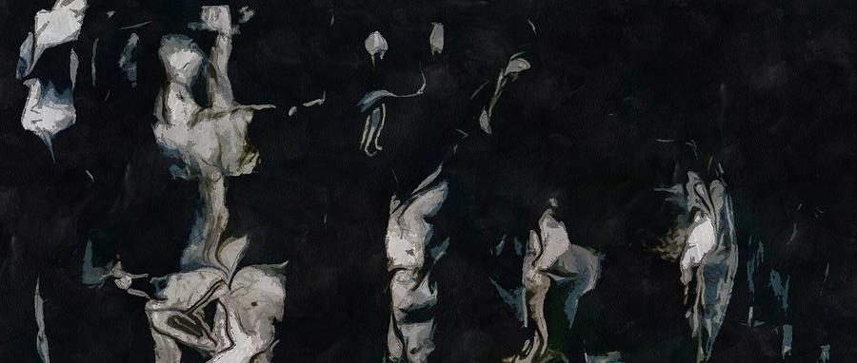

* I don't know why but the painting fits